Mechanical Inter-/Intra-Row Weeding Effect in Rice Transplanted in Wide Square Pattern

Monrawee Fukuda1, Rio Takama1, Toshiyuki Imaizumi1, Akira Koarai1

1National Agriculture and Food Research Organization (NARO)

Mechanical weeding is a labor-saving weed control method and a part of an integrated weed management system that allows farmers to reduce the use of herbicides including organic rice farming. Inter-row weeds can be easily controlled, while intra-row weeds are the challenge of mechanical weeding so hand weeding is used to control intra-row weeds. Reducing intra-row weeds and weeding costs are the main objectives for most organic rice production. Currently, mechanical inter-/intra-row weeding technology has been successfully developed. While widened intra-row can provide adequate space to improve mechanical weed control but the weeding period may be longer due to favorable conditions for weed growth. Little is known in this regard. Therefore, this study aimed to evaluate the weeding effect of mechanical inter-/intra-row weeding in wide square planting to provide suitable timing of weeding and weeding events for rice.

The experiment was carried out in the field (11a). The crop calendar for rice, soil puddling, fertilization, seedling, water, and mechanical weeding was managed under the organic farming scheme, while others (*i.e.* field ridge, autumn plowing) were under conventional management. Rice (*Oryza sativa* cv. Koshihikari) seedlings were transplanted in June 2022 and received 6 kg N 10a–1 of organic fertilizer (Yuuki-Aguretto 666) as a split application. Treatments consisted of (1) narrow planting (30 cm x 18 cm) + mechanical weeding equipped with the intra-row weeding tooth (The 1st, 2nd, and 3rd weeding; Inter-row weeding direction) and (2) wide square planting (30 cm x 30 cm) + mechanical weeding without the intra-row weeding tooth (The 1st weeding; Inter-row, the 2nd weeding; Intra-row, and the 3rd weeding; Inter-row and Intra-row weeding directions). The rice weeding machine had rotors and teeth as devices for inter-row and intra-row weeding respectively. The timing of weeding was 1, 2, and 3 weeks after transplanting (WAT) for the 1st, 2nd, and 3rd weeding, respectively. Treatments were laid in randomized complete block design with 3 replications. The experimental plot size was 99 m2. Six sample quadrats were designated in each plot to investigate weeds (*Monochoria vaginalis* and *Schoenoplectiella hotarui*). Each quadrat covered 0.108 m2 (for narrow planting) and 0.18 m2 (for wide square planting) or equaled the space in between 6 rice plants. At 11 WAT, the number and the dry weight of weeds growing in the inter-row and intra-row were investigated as illustrated in Fig. 1.

The results showed that the dry weight of weeds that remained after weeding was significantly low in the inter-row of narrow and wide square plantings (data not shown). The number of weeds in inter-row and intra-row was 84 and 300 m–2 for narrow planting and 115 and 290 m–2 for wide square planting, respectively. It implies that weeding was effective in inter-row. It appeared that weeding 2 times in wide square planting (B- and C-area), 3 times in narrow planting (A-area), and 4 times in wide square planting (A-area) largely reduced weeds with insignificant differences among these weeding events. Unremoved weeds largely remained around the base of the rice plants (wide square planting, D-area) because the area was not disturbed by weeding rotors (Fig. 2). This suggests that weeding at least 2 times could effectively control weeds (Fig. 2). Among 2-time-weeding events, the dry weight of weeds was lower in C-area than B-area, indicating a 2-consecutive-weeding at 2 and 3 WATs was relatively more effective than a 2-time-weeding at 1 and 3 WATs. In addition, the delay of the first weeding up to 2 weeks after rice transplanting may not negatively affect weed control if it is followed by a 2-consecutive-time of weeding.

Based on our data gathered so far, mechanical weeding was an effective method for weed control in wide square rice planting through 2 times of weeding. The timing of these 2 times weeding can be the important key to improving weeding efficiency. The first weeding employed 2 weeks after rice transplanting may not adversely affect weed control if it is followed by weeding 2 times continuously. Further study should concentrate on the suitable timing for weeding and a tool to remove weeds growing in the areas where mechanical weeding is not applicable.



Fig. 1 Weed observing quadrats in narrow planting **(A)**; A, Inter-row and B, Intra-row (3-time-weeded by teeth), and wide square planting **(B)**; A, Inter-row (4-time-weeded), B, Inter-row (2-time-weeded), C, Intra-row (2-time-weeded), and D, Intra-row/Base (unweeded), respectively.

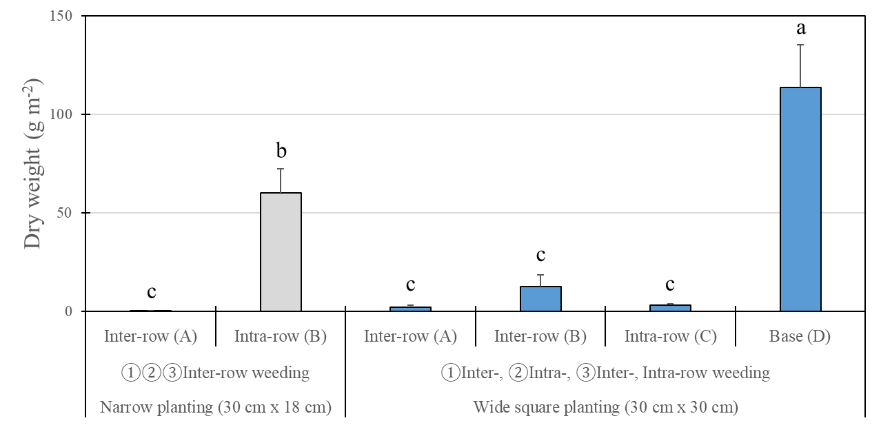

Fig. 2 Dry weight per unit area of weeds growing in different planting techniques in combination with mechanical weeding. Means with different letters are significant differences (*p* < 0.05, Tukey’s HSD).

**Key words:** high-efficiency rice weeding machine, inter-row weeding rotor, *Oryza sativa* cv. Koshihikari, weeding effect, weeding event

Co-responding author: Monrawee Fukuda

Position: Principal Scientist

Affiliations: National Agriculture and Food Research Organization (NARO)

Country: Japan

E-mail : [monrawee@affrc.go.jp](mailto:monrawee@affrc.go.jp)